PRIDE Panel Report
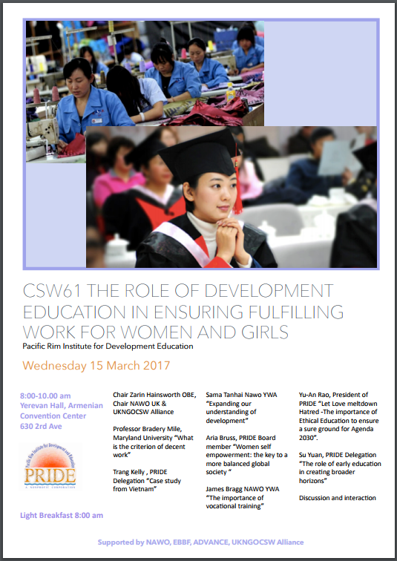
Report Front Page:
Executive Summary of the Event:
The central theme of the panel was primarily focused on the empowerment of women in the workplace and supporting women and girls through education into work. Sama Tanhai would go on to suggest not just physical development but the spiritual was needed as well. Aria Bruss-Schutte compared the recent rise of women and girls in education to the disproportionate number of women in leadership positions. Trang Kelly identified the relationship between the state, civil society and international funders when helping children in need. Yu-An Rao on the importance of ethical education in ensuring the success of Agenda 2030, and Su Yuan highlighted the importance of early education for the next generations. Finally, James Bragg who raised awareness to alternative pathways available to women and girls, rather than direct education streams.

Speaker Biographies:
Chair: Zarin Hainsworth OBE
1st: Sama Tanhai, NAWO YWA, “Expanding our understanding of development”
2nd: Aria Bruss-Schutte, PRIDE Board Member, “Women self-empowerment: the key to a more balance global society”
3rd: Trang Kelly, PRIDE Delegation, “Case Study from Vietnam”
4th: Yu-An Rao, President of PRIDE, “Let Love meltdown Hatred – The importance of Ethical Education to ensure a sure ground for Agenda 2030”
5th: Su Yuan, PRIDE Delegation, “The role of early education in creating broader horizons”
6th: James Bragg, NAWO YWA, “The importance of vocational training”

Speaker Notes:
Chair: Zarin Hainsworth OBE (Chair of NAWO UK and the UKNGOCSW Alliance)

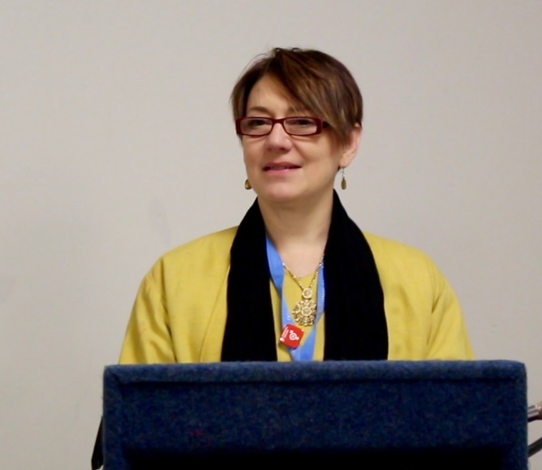
Chair:
Zarin Hainsworth OBE

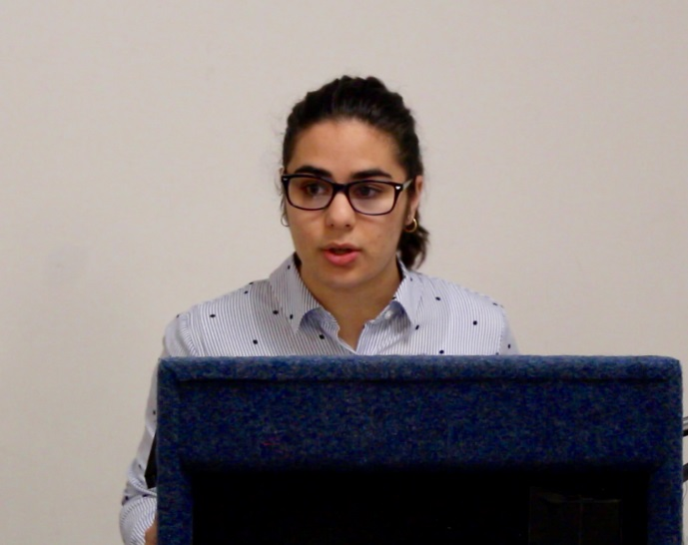
“Expanding our understanding of development”
Sama Tanhai, NAWO YWA

The first speaker was Sama Tanhai, a NAWO YWA delegate. She spoke about the need for an expansion in our understanding of development. She explained how, in our society of contest and material gain, there is a need for the Baha’i attitude of mutualism to prevent divisions. She told us about the impact of the Baha’i international community in one northern Indian town, where they provided education and handed out pamphlets to enable the locals to challenge the traditional gender roles. She shared how, as a result of this, the number of local schools increased, and the rate of early or child marriage and the discrimination between castes decreased. Sama closed with two key comments: we need to concentrate on not only physical development, but also spiritual; and we must start locally with changes, and then expand to a global impact.

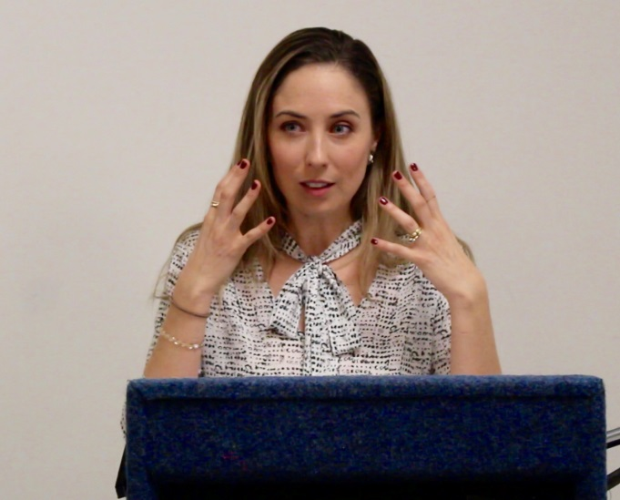
“Women self-empowerment: the key to a more balance global society”
Aria Bruss-Schutte, PRIDE Board Member

The second speaker was Aria Bruss-Schutte, a filmmaker and the producer of The Other Room and The International Comedian. She spoke about women’s self-empowerment and the possibilities it presents. She opened with a comment on how, despite the number and proportion of women in education has increased remarkably, there is still no, or very little, progress for women in leadership positions. She shared one experiment in 2003, where the same bio of a successful entrepreneur was given to the subjects, but when the name attached was Heidi, she was seen as self-serving, whilst the same information under the name of Howard made the candidate better to employ. Aria raised the issue that both men and women responded the same to that experiment, and talked about how internal barriers such as these are a by-product of their fight within oppressive systems, as women feel they need to be liked and so internalise the messages of non-aggression and lower power leading to an underestimation of themselves and a fear of expressing opinions.

For Aria, being educated and empowered means being smart about where the time and effort goes, being honest about where the system is working and where it isn’t, taking the time to speak up against it, not blindly following others but researching, questioning and debating, and balancing scientific and intuitive knowledge. She closed with to summarising points: first, empowerment begins with self-belief and self-sufficiency, as only then can we begin to support others; secondly, in order to make a change, we must acknowledge everyone’s role in it and take action, including praising others around us when we see improvements.

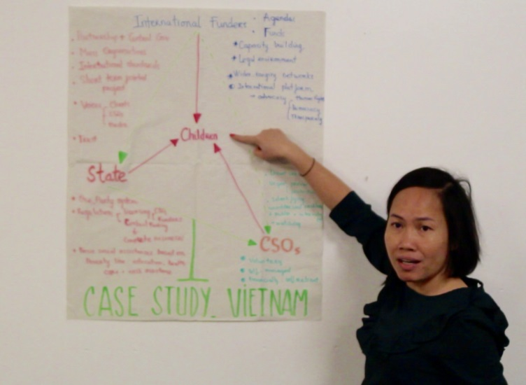
“Case Study from Vietnam”
Trang Kelly, PRIDE Delegation

The third speaker was Trang Kelly from Vietnam, who shared a case study from Vietnam. She was exploring the relationship between the state, civil society and international funders when trying to help a cause, in her case, children. She first talked about the key role that each party played. International funders brought the wide-ranging networks, funds and enabled an international platform for advocacy. CSOs were crucial for supplying direct services, identifying unaddressed or ignored issues, and acting as a watchdog. The state was important as it provided the basic social provisions, such as education, health care and cash assistance. Some problems she brought up from her experience in Vietnam were that the one party system made regulations harsh and restrictive, with CSOs and international funders needing to operate through the government, which enabled a control of funding. The solutions which Trang suggested were: building trust between all parties; creating mass organisations which would be more self-sufficient; applying international standards; using short-term joint projects; and giving more of a voice to CSOs, clients and the general media, to enable a more robust watchdog system.

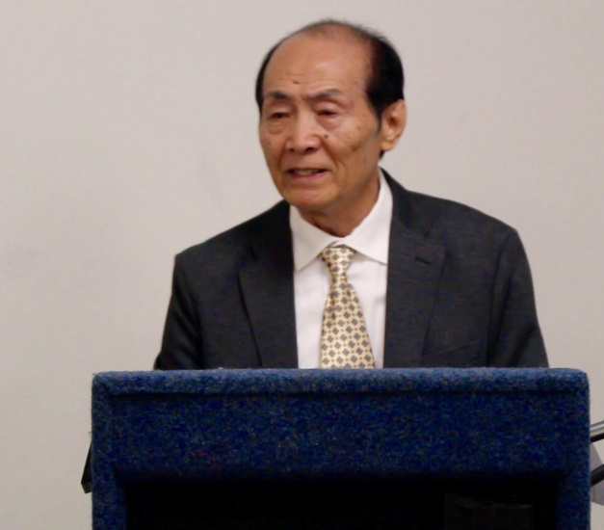
“Let Love meltdown hatred – The importance of Ethical Education to ensure a sure ground for Agenda 2030”
Yu-An Rao, President of PRIDE
Mr Yu-An Rao spoke next, on the importance of ethical education in ensuring the success of Agenda 2030. He began by speaking about how social relations increasingly cross borders, and how we need to move towards being a global family, using both scientific logic and either secular or religious morality to ensure sustainable world peace. He emphasised that is this goal was to be achieved, we needed to change our attitudes to thinking of ourselves as united in diversity and valuing and respecting the service we give to others more. He then discussed the importance of information, as we should not leap to conclusions without the full picture, and must not follow the inherited pattern of splitting people into categories, but learn to think independently. He closed with the idea that hatred hurts us all, so we should see ourselves as one to ensure the success of the SDGs.
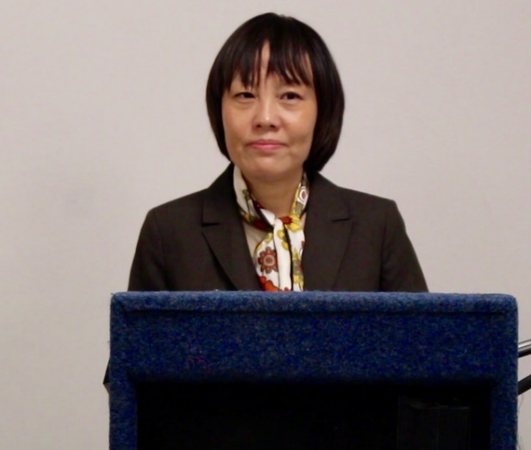
“The role of early education in creating broader horizons”
Su Yuan, PRIDE Delegation

Su Yuan was the next speaker, who spoke on the importance of early education in widening the horizons of the next generation. She first talked about how early education is crucial as it shapes character, but lamented the fact that too often there is a focus solely on skill development, which has meant huge improvements in science and technology, but resulted in us, for example, creating the technology needed to photograph forests from space, but also to chop them down. In Su’s view, education in tolerance, self-worth and environmental awareness would be crucial to try to change this. Early education provides opportunities to learn about others and shared core values while children are still young and less judgemental, while education over a long period of time through accepting children’s uniqueness, encouraging them to follow their dreams and allowing them to explore who they are can provide the self-assurance which prevents them from externalising the hate they feel towards themselves and directing it at others. She also felt that we have a duty to inform and educate the next generation in environmental awareness, teaching them that nature is a source of wonder and inspiration, not a resource. When all of those aspects of early education are implemented, Su Yuan believes that it will bring a brighter future.
“The importance of vocational training”
James Bragg, NAWO YWA

James Bragg, also a NAWO YWA delegate, was the final speaker at the event, and he talked about the importance of vocational training and VETs. First, James quoted the Beijing Platform for Action, which establishes education as a human right and encourages equality of access. Then he went on to discuss the barriers which prevent equality of access for girls: a gender imbalance in education (53% of girls versus 79% of boys in education in the Democratic Republic of the Congo), gender based violence (experienced by 10% of girls), the cost of education, child marriage and conflict situations can all disrupt education for girls and young women. He therefore concluded that more schooling may not solve the issue and ‘leave no one behind’. VETs, being both paid and less age-specific than traditional forms of education, may help to bridge the gap, in James’ view, so should not be neglected as an option.

